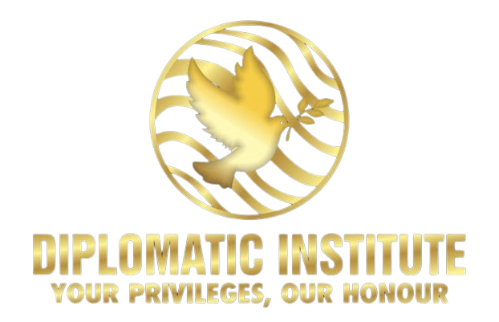
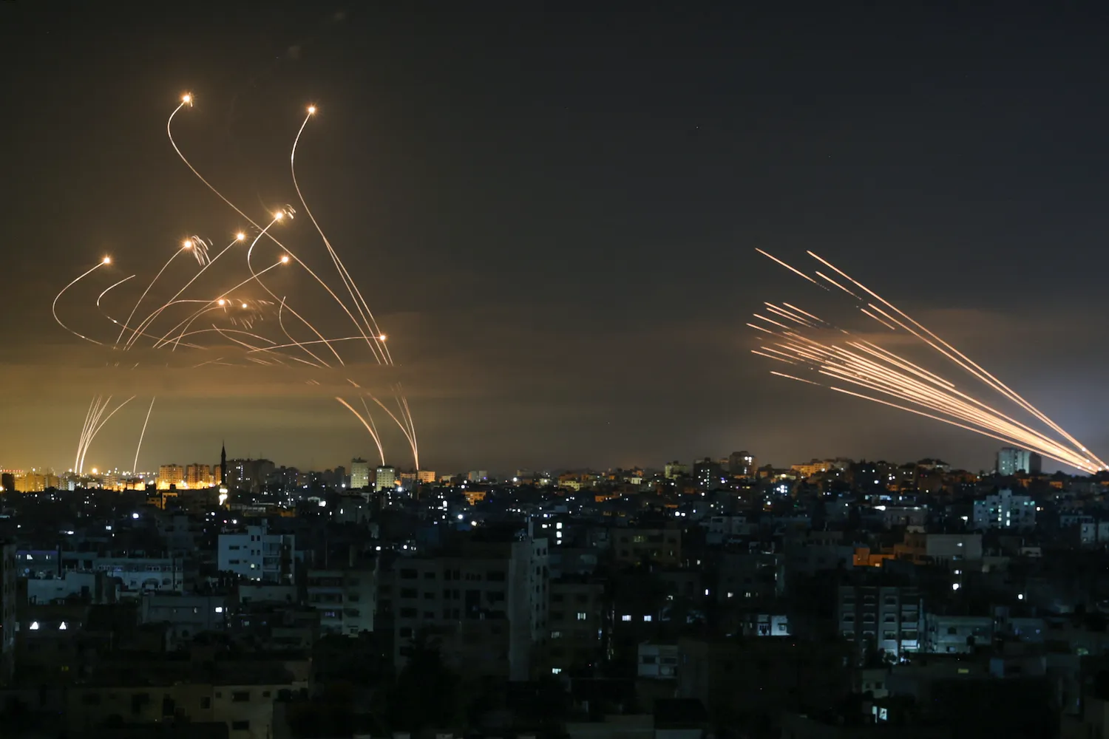

IRON SWORDS – NAVIGATING IN TROUBLED WATERS
TOOLKIT

Abstract:
The Hamas attack on 7 October broke all the rules of the game in the long-standing conflict with terrorism. The ensuing war heightens tensions, and the conflict spills over into your companies, increasing the number of objections. Face to this situation, I would like to share with you the crisis management formula that I use successfully to handle any objections and ensure business continuity.

Gabriel Hayon
info@diplomaticinstitute.org
OPENING REMARKS

A challenge for the international sales manager who knows all types of objections. You are skilled salespeople who have heard and practiced answering all the objections in the book.

However, how do you respond to an employee, college or customer who tells you they like your product but refuse to do business with "a terrorist state that bombs a hospital"? How do you respond to an employee who tells you he feels uncomfortable continuing to work for an Israeli company that supports the colonization and oppression of the Palestinian people? What do you say to a Turkish client who says he feels uncomfortable working with Muslim haters, or to a European who elegantly filters all media?

Moment! Do not give inflammatory answers of "show them", "expose the lie of Hamas". Don't bother sending videos that show our suffering and don't present Israel as a tormented victim! And a shop will only fortify them in their position and getting closer will not result in an invitation out of pity. Remember that we're not in Parliament or in a debate, but in a complex business reality. Customers are free to choose between suppliers from different countries, and their "activation buttons" are not only rational but also emotionally influenced by the news and differentiate between Moshe Rabbinu and Moshe Dayan. The same can be said for your international employees.

Since every year, we have to face this unsympathetic situation of canceling orders due to the situation, I would like to share with you the crisis management formula that I use successfully.

The goal in this tactic is to neutralize the resistance and not confront it: My honest answer to the Brazilian customer is that "I too feel the pain of the murder of children on both sides of the border and pray together with you, dear customer, that the bloodshed in our regions and everywhere else will stop." And Turki "I learned from my grandmother that the root of the word 'Islam' is... 'peace', so I have no hatred for the people of peace."

The method works wonders. It neutralizes and defuses any objection because it is personal and details the emotional veins of your interlocutor. Of course, the message must be accompanied by sympathetic and positive body language that complements the message and does not contradict it. Every email from the Brazilian opened with the sentence "My dear peace-loving friend" and the Turk opened his heart to me.

In this toolbox, you'll find the keys to my strategy for dealing with any objections, whether from a customer or one of your internationally based employees. You'll also find resources to help you talk about 10/07 in a sensitive and effective way.

INTRODUCTION

The Hamas attack on 7 October broke all the rules of the game in the long-standing conflict with terrorism. The Hamas attack was a veritable massacre, resulting in over 1,400 dead, 3,100 injured, and 200 captured. The attack involved more than 3,000 terrorists armed to the teeth and thousands of rackets across most of the country. Hamas used a brutality never before seen in Israel or anywhere else in the world, practices borrowed from ISIS. As a result, Israel has decided to eliminate Hamas.

The war Israel has embarked upon is not just to protect itself against Hamas, but to prevent the conflict from going international and the Islamist threat from reaching Europe's doorstep. Israel is the first line of defense against the spread of hate and violence.

Israel is not at war with Palestinians. Israel is at war with terrorists’ groups that murders innocent civilians in the name of Palestinians rights. Under international law, Israel has every right to defeat Hamas military and we hope it will for Israelis and Gazans.

The events of October 7 are not just another round of escalation in the Israeli-Palestinian conflict. The stakes extend beyond borders and national concerns. As Israeli President Isaac Herzog wrote in his letter to the presidents of American colleges and universities on November 7, this is a “litmus test for the protection of humanist and liberal values in the enlightened world”: “This conflict is far more than a clash between Israel and Hamas: At stake is whether the enlightened world will defend the basic norms of humanity, or choose to accept, even support, their violation”.

Targeting the Jewish community. Since the Hamas attacks in Israel on October 7, and the start of the war between the Israel and the Islamist movement in the Gaza Strip, anti-Semitic acts have multiplied in Europe and elsewhere.

Anti-Semitism is rising from the ashes, and some of your employees may be affected more than you think. This toolkit will also help you respond to the many manifestations of anti-Semitism and create a safe and fair space, not only for your employees, but for the world at large.

THE COMPLETE BUSINESS CONTINUITY GUIDE AND TOOLBOX DURING IRON SWORDS

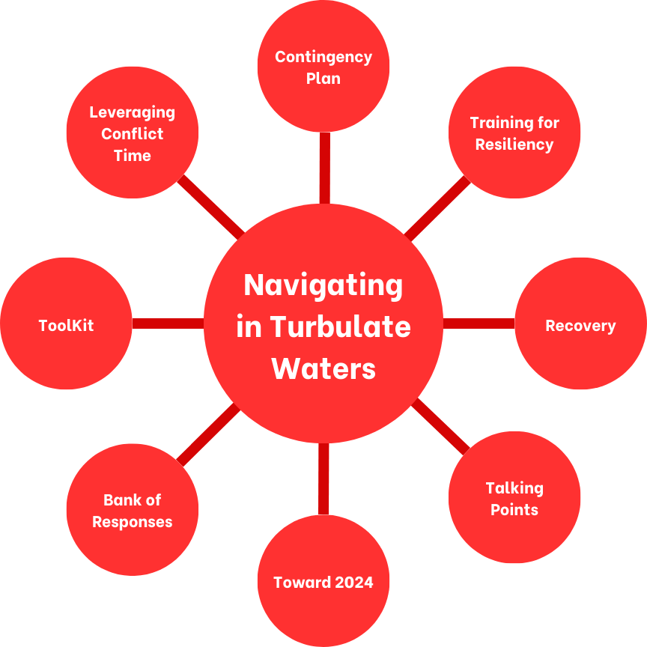

HOW TO SPEAK OUT ABOUT 10/7 IN A SENSITIVE AND IMPACTFUL WAY WITH EMPLOYEES AND COLLEAGUES

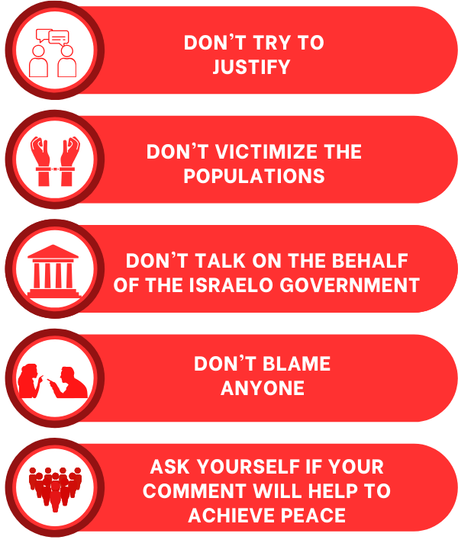
The key to building an unambiguous and reasoned response that neutralizes and defuses any objections is to detach your speech from any personal feelings that may resonate with the person you are talking to.

The Israeli-Palestinian conflict is a subject that arouses strong emotions, whether because of personal ties, political convictions, or empathy for the people involved. Mastery of language and choice of words is crucial to avoid arousing emotions in the person you speak to, which could turn your discourse against you.

How can you avoid this?

On the one hand, don't try to justify anyone's actions and avoid victimizing people. You could strike a chord, blocking any further discussion with the person you are talking to.

Secondly, be clear in what you say and make sure, from the start of your reply, that the person you are talking to understands that you are not speaking on behalf of the Israeli government. Your response is your own, and you are not relaying the views of anyone else.

In addition, be careful not to blame anyone. Once again, the aim is to ease tensions and ensure business continuity. You're bound to fail if you persist in blaming so-and-so.

Finally, before talking to the person you are talking to, ask yourself whether what you are saying will make a positive contribution to the establishment of a calmer environment within your company and a more peaceful world.

WHAT TO DO NOW?

The ongoing war against Hamas is also affecting our companies and the way we do business. Our teams and subsidiaries are falling apart, we can't get to our customers, we face some problems with certain employees… We have to adapt to the situation.

This toolkit aims to shed light on the measures you should take to ensure business continuity during these uncertain times. Whether it's your customers, your suppliers, your operations or your employees, here are the different tools you can adopt to improve the business’ resilience and don't let the situation overwhelm you.

A war of Iron Swords requires nerves of iron. Our strength will be measured by our ability to face up to this crisis and to lead the recovery quickly.

Here are some tips to help you along the way:

- Build your marketing strategy, should include a Brand and an Awareness book, as well as a Positioning Market Study and a Market Research.

- Risk Assessment will ensure business continuity, while preparedness plans will assess possible scenarios to adapt to changing circumstances.

- Adapt your message to War Time: many opportunities can arise from a time of crisis. Ask yourself this question: How to create new opportunities out of this crisis? What are the needs and demands in this new context? How can I shape my offer and my activity to meet these demands?

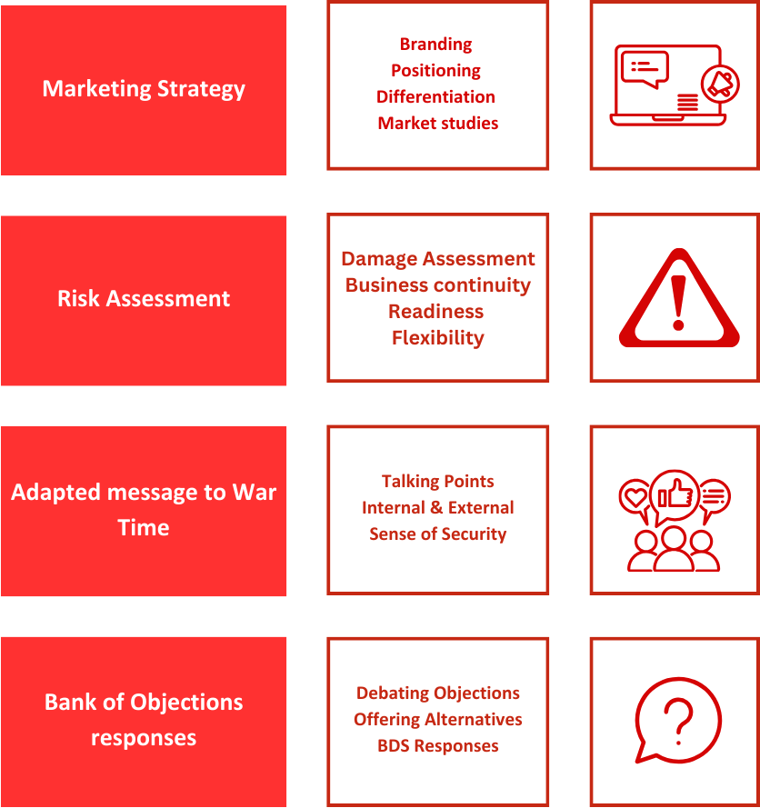
- Build a Bank of Objections Response: Prepare answers in advance to counter all kinds of objections. This way, you minimize the chances of being surprised and unsettled. By preparing your answers in advance, you put all the chances on your side to keep control of the discussions, while avoiding stirring up tension.

- Prepare an Exit Strategy Prepare an Exit Strategy to Overcome challenges, create independency, adapt supply chain and streamline Processes.

- Prepare an Annual Plan for 2024: drawing up an Annual Plan will help you and your team to succeed in the year ahead by setting clear objectives and a strategy for achieving them. This plan must include a Recovery section and target New Markets. Draw up a plan for the post-war era: Resize & Rightsize, Restructure & Delegate.

- Develop a Communication Strategy: Its vital to Build Trust and Assure accountability through a Clear communication and regular Update on status. Commit to Deliver.

- Mitigate the Risks: Monitor the situation Assess challenges, Limit liabilities, Activate Insurance.

For jobseekers, this period of crisis can also be a good opportunity. Put all the chances on your side by updating your CV and LinkedIn profile. The professional platform will be your best ally in navigating these troubled waters.
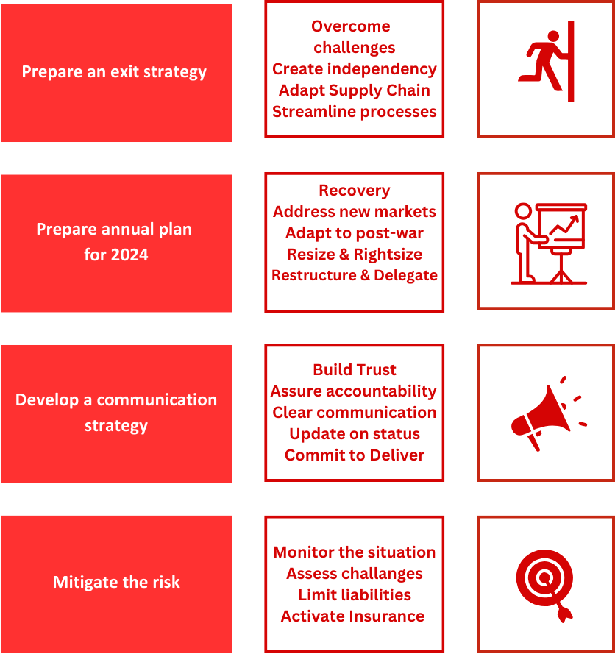
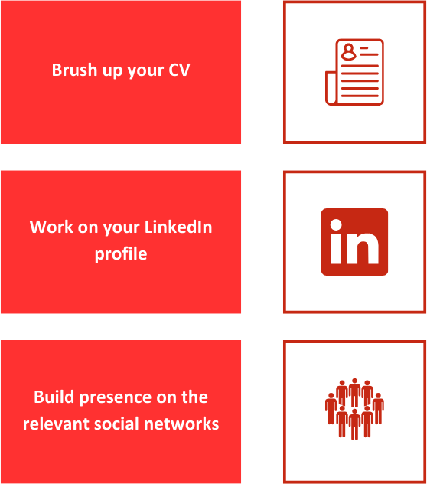
What’s the next step?
What should I do?

Here are a few tips on corporate leadership in times of crisis:
- How to separate my area of control from that which is not under my control
- How to break down each challenge and prioritise between important and urgent
- How to draw up work plans in conditions of uncertainty
- How to list execution plans and follow-up tasks
- How to lead teams to success.

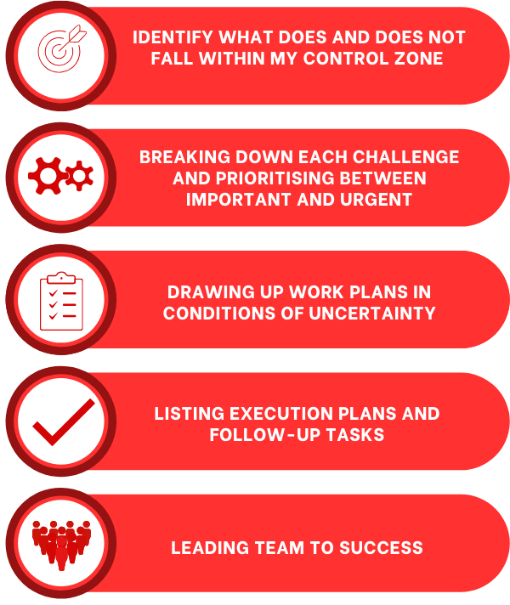
To find out more about this course, please visit the Diplomatic Institute website to discover more contents available on “Navigating in Troubled Waters”.
EXPLORING BUISNESS OPPORTUNITIES IN WARTIME

The Business Opportunities
What problem are you solving? What challenges and pain point will you resolve for users? Explore new business opportunities in the new context of war. Which sectors should you focus on? What are the new needs?

Company Description Team
What does your company do? Who is involved in this endeavor?
What challenge(s) does your company solve? Who is on your team?

Industry Analysis
Who are you competitors?
What are some key factors related to being in your industry?

Target Market
Who are you targeting? What makes up your target audience?
Who are your target segments, buyers’ personas and ideal customers?

Marketing Plan Funding Required
Which channels and plateforms will you use to What amount of Funding will you
Reach and convert your target audience? Required from investors?
THE HAMAS-ISRAEL WAR SCOPE EXTENDS FAR BEYOND THE LOCAL AREA

The intense fighting in the Middle East, so close to the Egyptian border and not very far from the border between Saudi Arabia and Jordan, is projecting negatively on all countries in the region, and the risk of regional war is growing.

- Locally: Israel and Palestine, an urge to free Palestine from Hamas

- Regionally: the Arab world is destabilized by street protests and public resentment of the Palestinian cause (rise of radical Islam through active groups close to Hezbollah and the Iranian regime spreading hate not only to Israelis and Jews but to western countries/way of life…; leadership crisis in the Arab world (especially in States wishing to cooperate with Israel: Egypt, Morocco, UAE, Bahrain)

- Globally: Europe is next door, the western world is next door (the geopolitical consequences are global, Hamas’ attack on 7th October impacting many countries in various aspects, security, economy, immigration…).

THE NEED TO PRESERVE ISRAEL AS AN ASSET – THE IRON DOME OF THE WEST AGAINST THE IMPERIALIST ALLIANCE LED BY IRAN

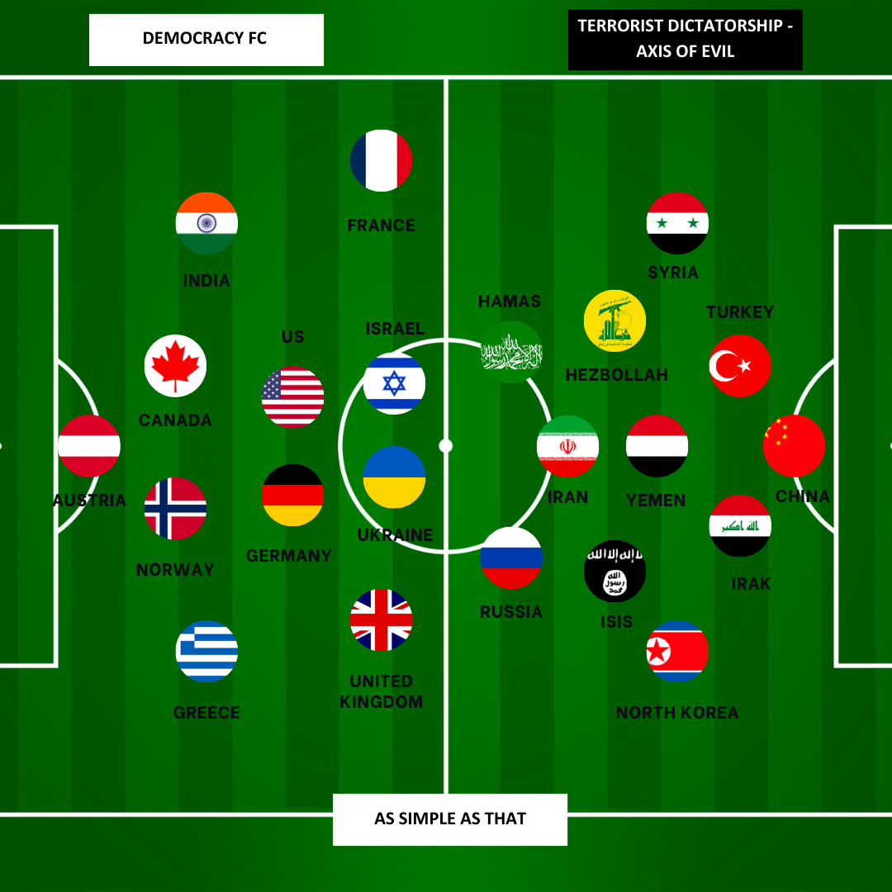
The events of October 7 are not just another round of escalation in the Israeli-Palestinian conflict. The stakes extend beyond borders and national concerns. As Israeli President Isaac Herzog wrote in his letter to the presidents of American colleges and universities on November 7, this is a “litmus test for the protection of humanist and liberal values in the enlightened world”: “This conflict is far more than a clash between Israel and Hamas: At stake is whether the enlightened world will defend the basic norms of humanity, or choose to accept, even support, their violation”.

It is vital to preserve Israel as asset to protect the western countries and values against the spread of radical Islamic violence worldwide. Israel as the first rampart against the axis of evil, both geographically and strategically.

- A common enemy - Radical Islam: Israel as a "forward outpost" of the "West" or the free world in the face of the regional threats facing the Europeans from the Russia-Iran axis (valued military, weaponry, and intelligence capabilities that are attractive to NATO member states).

- Hamas is a proxy of Iran: Hamas is a part of an imperialist alliance: Iran, Qatar and Turkey give hundreds of millions to arm and fund Hamas. Iran is an Islamist Imperialist state that rules over other peoples on their indigenous territories such as Kurds, Azeris and Balouches. The murder of Mahsa Amani is one example of Iranian imperialism and Islamism.

- Hamas, Iran and Hezbollah: Iran gave Hezbollah over $700 million a year. Tehran also gave over $100 million annually to Hamas and the Islamic Jihad. Hamas is backed by powerful nations like Iran, who want to eliminate non-Islamic peoples in the Middle East and disregard Palestinians lives. Hamas has massive amounts of support.

- Preventing a wave of mass immigration to Europe: advocating for the de-escalation of the conflict to stem another wave of refugee migration to Europe

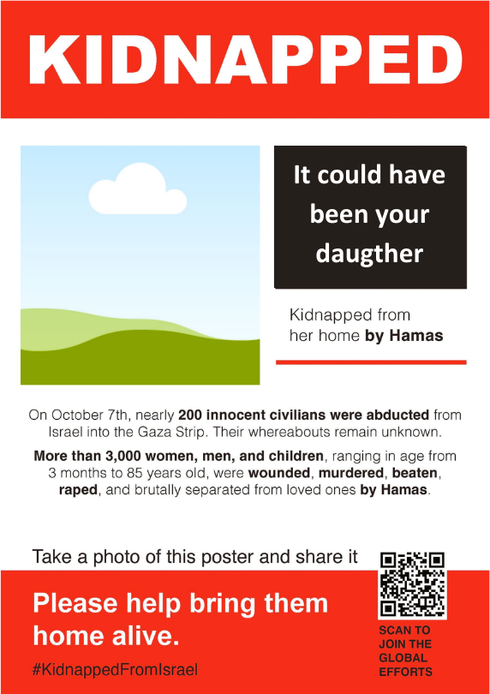
- Bringing home their citizens taken as hostages: many hostages have dual Israeli and European citizenship. Despite its lack to direct influence on Hamas due to its designation as a terrorist organization 20 years ago, Europe could indirectly influence Hamas through its relations with Qatar to bring them home.

- Preserving domestic stability in nearby countries: Arab world (prevent the Muslim Brotherhood to extend and gain influence in the Gulf countries for exemple), the Hellenic Alliance (immigration, gas export and threats on the Tamar reservoir), Morocco (shadow over the nation's priorities, growing radical domestic forces seeking to exploit the Israel-Hamas conflict for their own political gain, growing influence of Iran)

- A threat to the Israel-Egypt relationship, guarantors of security in the region: Israel’s key Middle East relationship with Egypt is crucial for coordinating actions, and a deterioration could threaten moderate Arab states and limit Israel's Gaza actions.
- Preserving domestic stability in European countries: internationalization and recuperation of the conflict by different groups, political parties, individuals… creating a frightening divide within European societies, communitarianism and the spread of hatred and violence.

- Europe is next door: the spread of anti-European/western sentiment (protests in front of French and US embassies around the world, bomb scares in many French museums in the days following the start of the war, terrorist attack in Arras in France the day Hamas called for an international jihad - 13th of October).

- The Ukrainian War: two wars at the same time but a common enemy (Russia). EU needs US escalation on Ukraine: escalation could stretch US capabilities and divert attention from Ukraine, letting Europe more vulnerable to Russian ambitions. The worst thing for Kiev would be to be subjected to a creeping reconquest by Russia, in the silence of the international community. The links between Hamas and Russia are well established. Russia's support for Hamas is not only diplomatic, but also military, strategic and logistical (supply of weapons, military vehicles, training provided by the Wagner group).

- Preventing a potential threat to the global economy: risk of partial/full paralysis of the oil supply chain and significant rise in the price of a barrel of oil

- Preventing a humanitarian catastrophe forcing millions of civilians to Europe, provoking a major new migratory crisis.
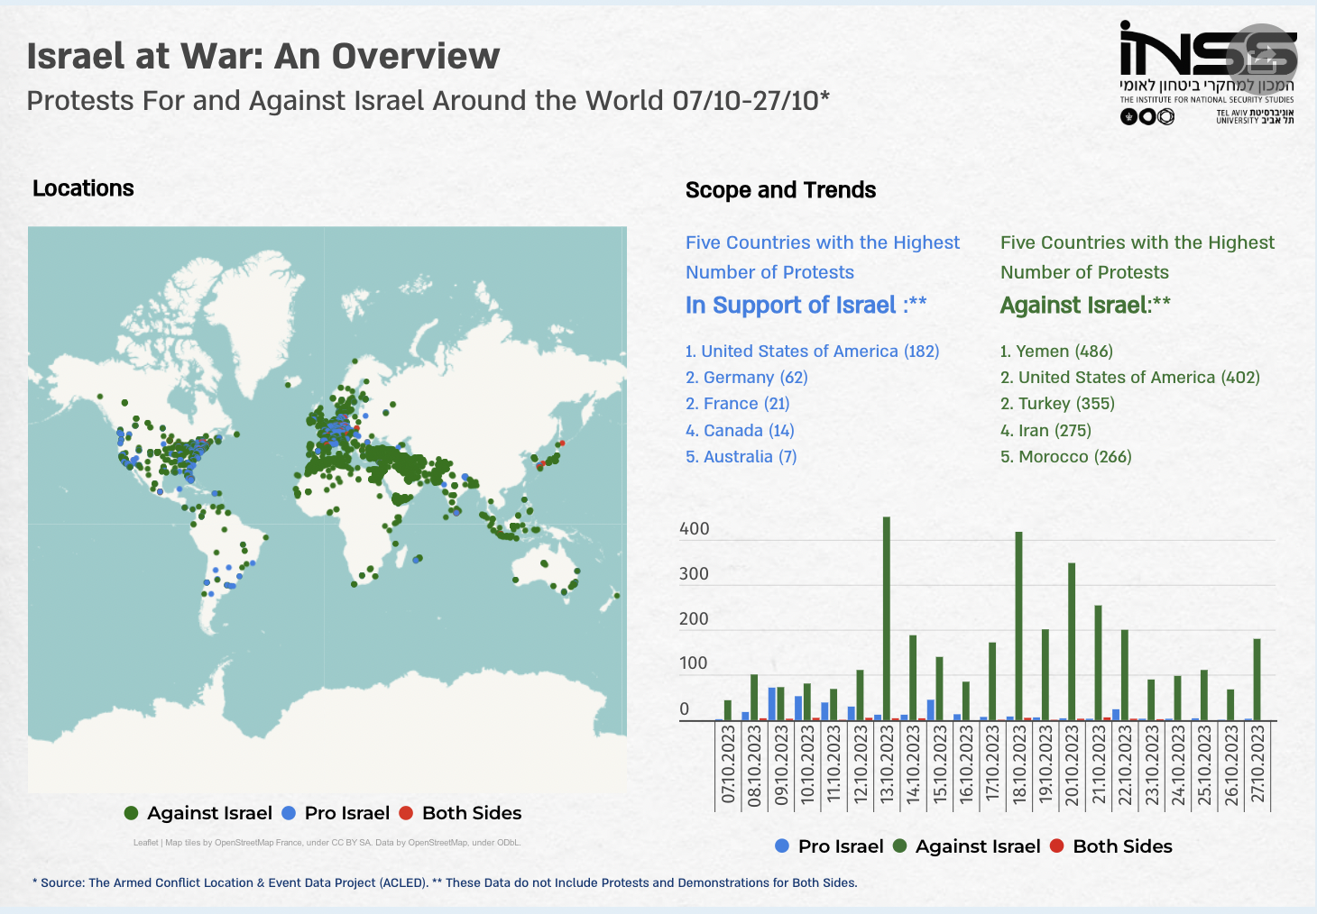
“This conflict is far more than a clash between Israel and Hamas: At stake is whether the enlightened world will defend the basic norms of humanity, or choose to accept, even to support their violations”.
President Isaac Herzog, Nov 7th, 2023.

Ehud Rosen et Shahar Eilam, « The War in Gaza and the Domestic Threat in the West », INSS, INSS Insight, nº 1786 (15 novembre 2023).
Ehud Rosen et Shahar Eilam, « The War in Gaza and the Domestic Threat in the West », INSS, INSS Insight, nº 1786 (15 novembre 2023).
Arkady Mil-Man et Bat Chen Druyan Feldman, « Russia-Hamas Relations and the Israel-Hamas War », INSS, INSS Insight, nº 1784 (9 novembre 2023), https://www.inss.org.il/publication/russia-hamas-israel/.

